Costa Rica Glass

Julie M. Coulombe

2/25/2020

An analysis of volcanic glass sampled from the Tajo La Florida quarry at Barva Volcano in Costa Rica. Samples collected are from potentially different lava flows. Data was acquired by using an electron microprobe.

Data points were constrained as follows:

Wt% Totals > 95.0 and < 101.0  
SiO2 < 90.0  
Al2O3 > 10.0 and < 22.0  
K2O > 1.0

Create plot for SiO2 vs Na2O + K2O by each rock 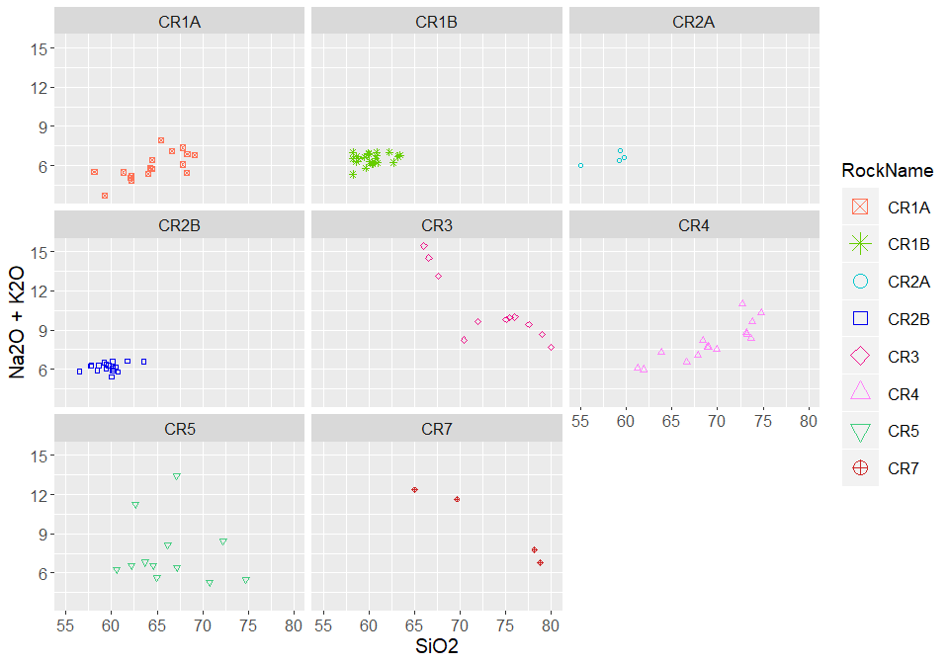

Create plot for SiO2 vs Mg# by each rock 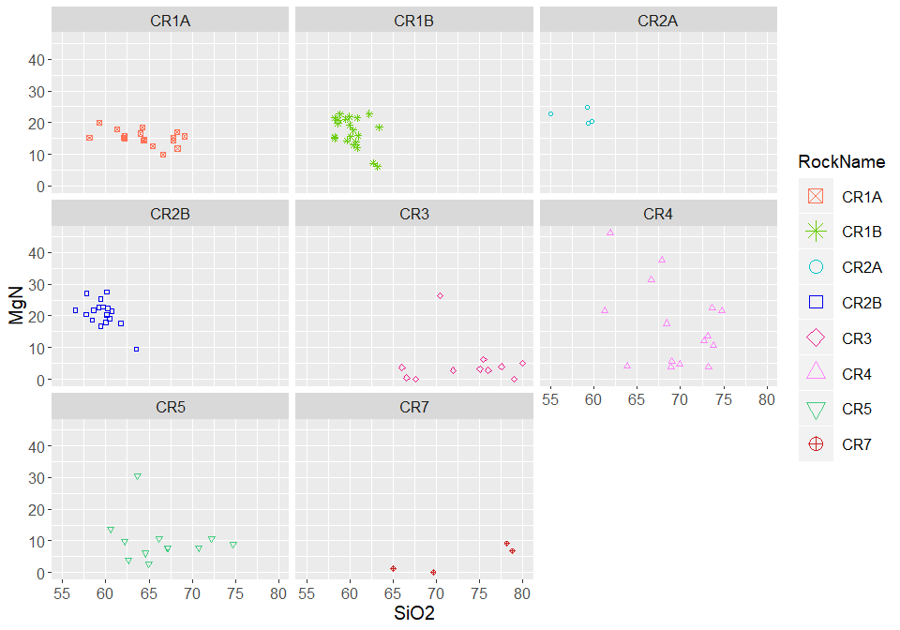

Create plot for SiO2 vs FeO by each rock 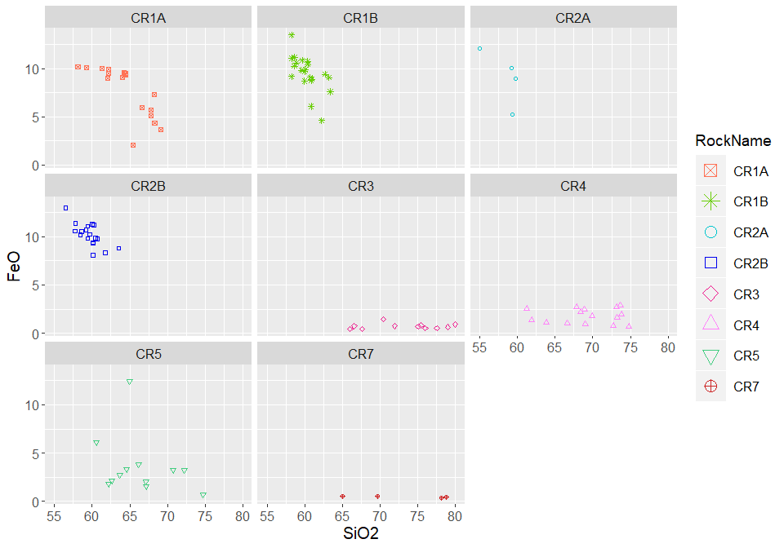

Create plot for Al2O3 vs TiO by each rock 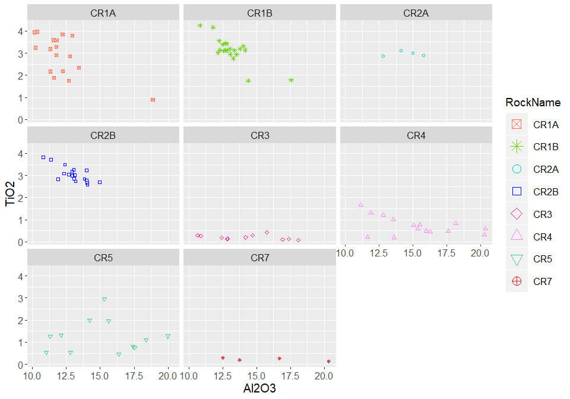

Plot Alkali by Rock Name 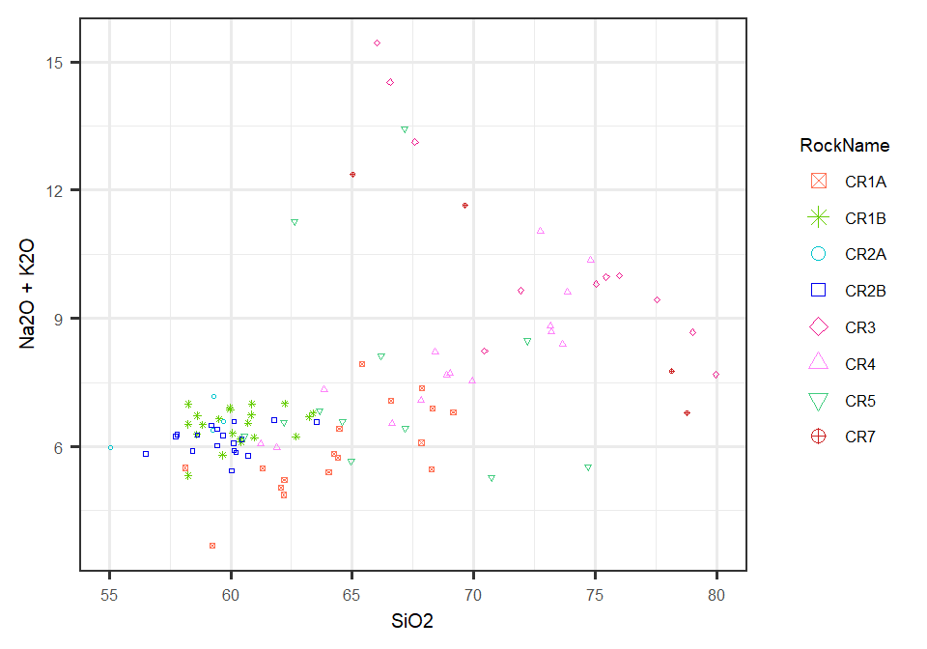

Overlay Alkali Plot on TAS Diagram 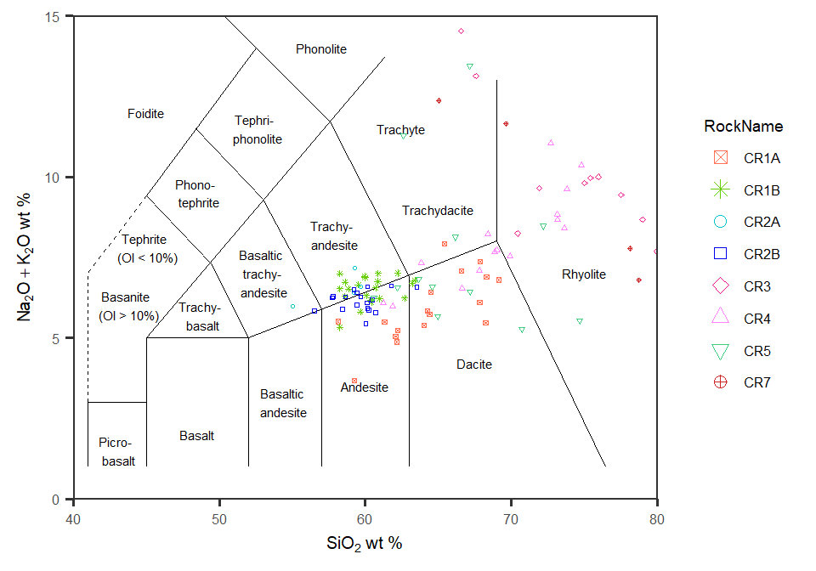

Now to look at plots of all rocks together

Plot Silica vs Mg# by rock 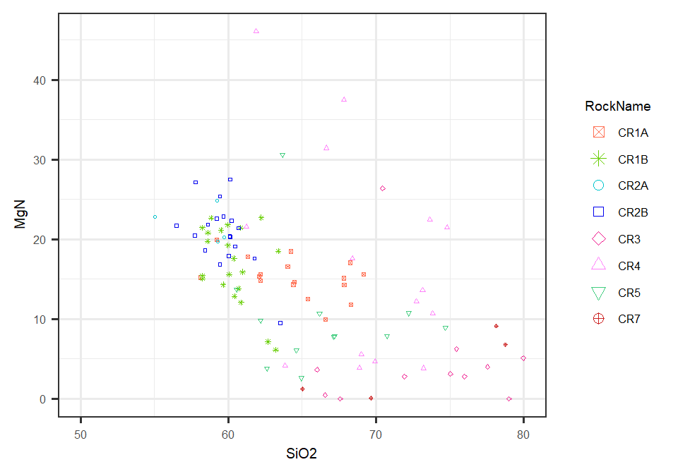

Plot Silica vs Iron by rock 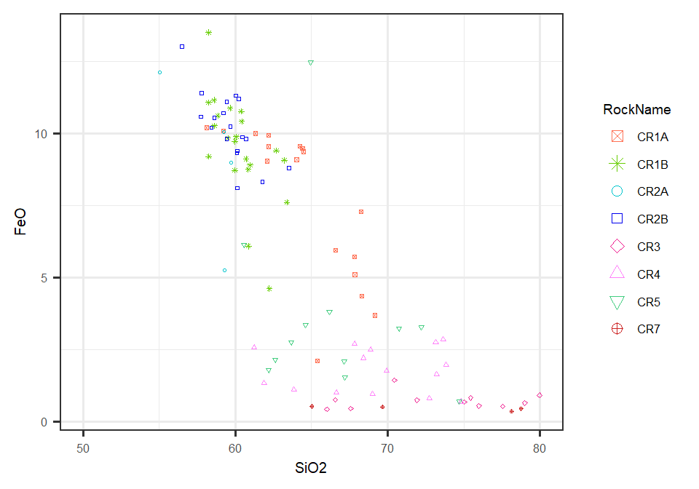

Plot Aluminum vs Titanium by rock  
(the mean and standard deviation of each is in table below) 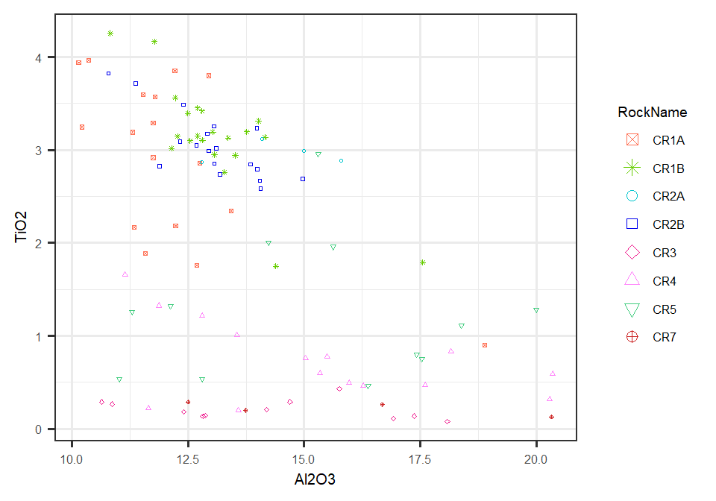

|  |  |  |  |  |
| --- | --- | --- | --- | --- |
| **RockName** | **Al2O3mn** | **Al2O3sd** | **TiO2mn** | **TiO2sd** |
| CR1A | 12.174 | 1.964 | 2.910 | 0.899 |
| CR1B | 13.117 | 1.314 | 3.139 | 0.581 |
| CR2A | 14.424 | 1.282 | 2.965 | 0.115 |
| CR2B | 13.036 | 1.042 | 3.047 | 0.353 |
| CR3 | 14.239 | 2.563 | 0.206 | 0.104 |
| CR4 | 15.275 | 2.924 | 0.729 | 0.421 |
| CR5 | 15.177 | 2.920 | 1.247 | 0.744 |
| CR7 | 15.810 | 3.481 | 0.219 | 0.072 |

Switching gears and taking a look at the bulk composition of the rocks themselves.